Asimov The Best of Isaac Asimov, Doubleday Stated First Edition 1974 (Gutter code P29 – July 1974). As new clipped dust jacket in mylar. As new hardcover with all 294 pages tightly bound with no marks of any kind. Art by Richard Mantel. ISBN 038505078x
Isaac Asimov offers in this collection twelve of the best stories he has written over the past thirty-five years from Marooned Off Vesta published in March 1939 in Amazing Stories magazine to Mirror-Image in May 1972 in Analog Science Fiction and Fact.
ID 000289 Price $150 Box 27

AbeBooks new $353, Used First from $75 to $300 signed bad DJ,
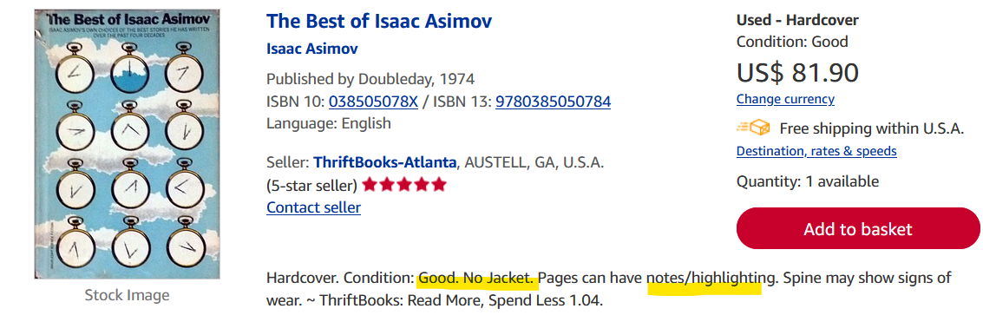
Thrift readable $81

